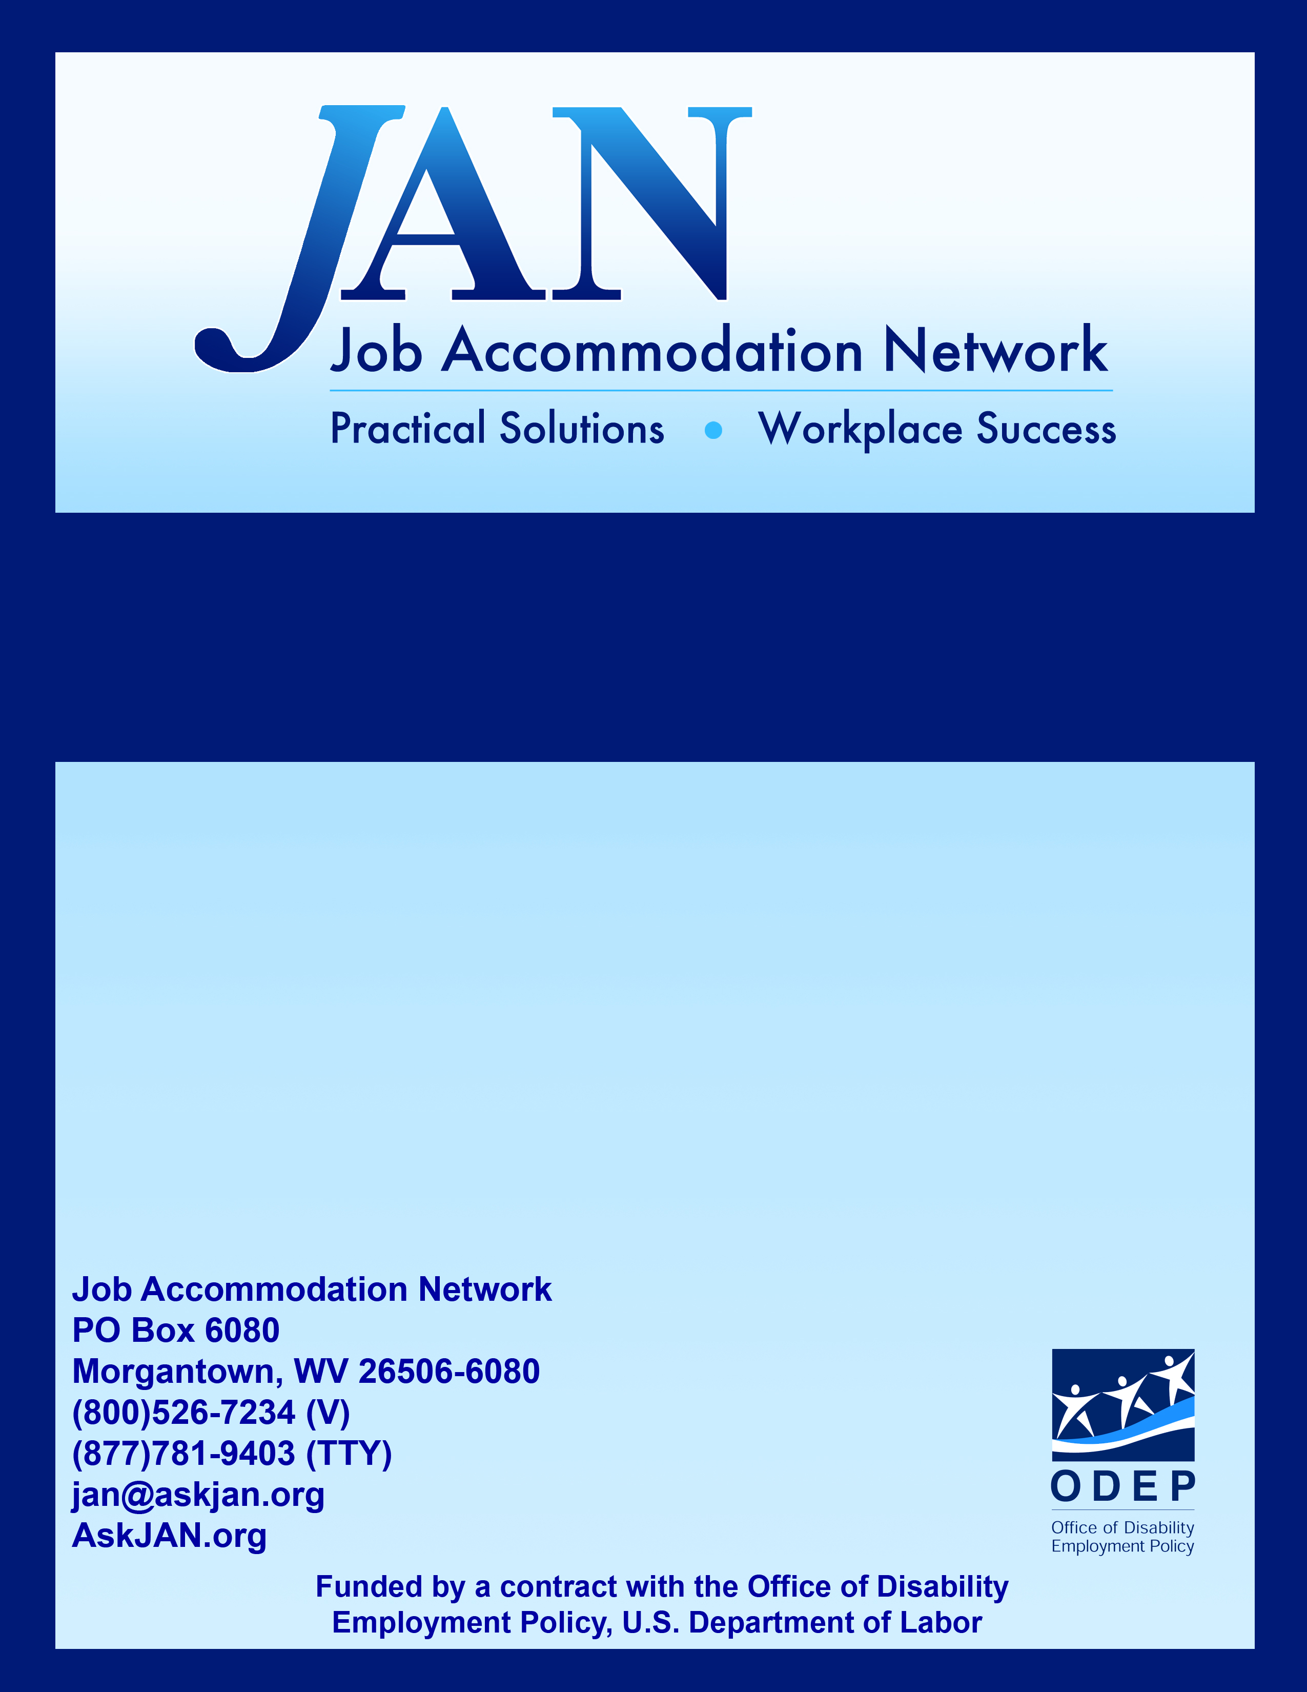
Employees with
Executive Functioning Deficits

Effective Accommodation Practices (EAP) Series

JAN’S EAP SERIES

Employees with Executive Functioning Deficits

As the name suggests, executive functions are high-level mental processes or abilities that influence and direct more basic abilities like attention and memory. The term executive function describes a set of cognitive abilities that include the ability to plan, organize and strategize, pay attention to and remember details, start and stop actions, and form concepts and think abstractly.

Executive functions also keep us from behaving in inappropriate ways. People with poor executive functions have difficulty monitoring and regulating their behaviors. These difficulties can include monitoring and changing behavior as needed, planning future behavior when faced with new tasks and situations, and anticipating outcomes and adapting to changing situations. People with poor executive functions will often have problems interacting with others and fitting in socially (Encyclopedia of Mental Disorders, 2014).

Executive function deficits can be found in individuals with mental health impairments including depression, obsessive-compulsive disorder, post-traumatic stress disorder, and schizophrenia, as well as individuals with attention deficit disorder, attention deficit/hyperactivity disorder, intellectual and learning disabilities, autism, and brain injuries.

The following is a quick overview of some of the job accommodations that might be useful for employees with executive functioning deficits. For a more in depth discussion, access JAN's publications at https://AskJAN.org/a-to-z.cfm. To discuss an accommodation situation with a consultant, contact JAN directly.

Time Management: Individuals may experience difficulty managing time, which can affect their ability to mark time as it passes incrementally by minutes and hours. It can also affect their ability to gauge the proper amount of time to set aside for certain tasks. As a result, it may be difficult to prepare for, or remember, work activities that occur later in the week, month, or year.

- Divide large assignments into several small tasks or chunks
- Set a timer to sound an alarm after assigning ample time to complete a task
- Provide a checklist of assignments
- Plan and structure times of transition and shifts in activities
- Supply an electronic or handheld organizer and train on how to use it effectively
- Use a wall calendar to emphasize due dates
  - Develop a color-coded system (each color represents a task, or event, or level of importance)
  - Allow co-worker or supervisor to add entries on the calendar or to double-check entries added by the employee

Memory: Individuals may experience memory deficits, which can affect their ability to complete tasks, remember job duties, or recall daily actions or activities.

- Provide written instructions and checklists
- Allow use of a recorder
- Allow additional training time for new tasks
- Offer training refreshers
- Provide minutes of meetings and trainings
- Use flow-chart to indicate steps in a task
- Provide verbal or pictorial cues
- Use a color coding scheme to prioritize tasks
- Use notebooks, planners, or sticky notes to record information
- Use sticky notes as reminders of important dates or tasks
- Provide labels or bulletin board cues to assist in location of items

Concentration: Individuals may experience decreased concentration, which can be attributed to auditory distractions and/or visual distractions. Distractions such as office traffic and employee chatter, opening and closing of elevator doors, and common office noises such as fax tones and photocopying can be problematic.

- To reduce auditory distractions:
  - Provide a noise canceling headset
  - Hang sound absorption panels
  - Provide a white noise machine
  - Relocate employee’s office space away from audible distractions
  - Redesign employee’s office space to minimize audible distractions
- To reduce visual distractions:
  - Install space enclosures (cubicle walls)
  - Reduce clutter in the employee's work environment
  - Redesign employee’s office space to minimize visual distractions
  - Relocate employee’s office space away from visual distractions
- Breaks for mental fatigue, including short walks, getting up for a drink of water, and rotating through varied tasks
- Job restructuring so the most difficult tasks are performed at the time of day the employee has the most mental energy or stamina

Organization and Prioritization: Individuals may have difficulty getting or staying organized, or have difficulty prioritizing tasks at work.

- Develop color-code system for files, projects, or activities
- Use a color coding scheme to prioritize tasks
- Use weekly chart to identify daily work activities
- Use a job coach to teach/reinforce organization skills
- Assign a mentor to help employee
- Allow supervisor to assign prioritization of tasks
- Use electronic organizers, mobile devices, and e-mail reminders
- Assign new project only when previous project is complete, when possible
- Provide a “cheat sheet” of high-priority activities, projects, people, etc.
- Organize work space to reduce clutter
- Provide separate work areas with complete sets of supplies for differing tasks
- Schedule a weekly time to clean/organize work space
- Take time at the end of each day to organize and set up for the next day

Multi-tasking: Individuals may experience difficulty performing many tasks at one time. This difficulty could occur regardless of the similarity of tasks or the frequency of performing the tasks.

- Separate tasks so that each can be completed one at a time
- Create a flow-chart of tasks that must be performed at the same time, carefully labeling or color-coding each task in sequential or preferential order
- Provide individualized/specialized training to help the employee learn techniques for multi-tasking (e.g., typing on a computer while talking on the phone)
- Identify tasks that must be performed simultaneously and tasks that can be performed individually
- Provide specific feedback to help the employee target areas of improvement
- Remove or reduce distractions from work area
- Supply ergonomic equipment to facilitate multi-tasking
- Clearly represent performance standards such as completion time or accuracy rates

Paperwork: Individuals may experience difficulty completing paperwork efficiently and effectively. This may be due in part to workplace distractions and difficulty with time management, disorganization, or prioritization.

- Automate paperwork by creating electronic files when possible
- Use speech recognition software to enter text or data into electronic files
- Save time filling out paper forms by completing information in advance, using pre-filled forms, or adhering pre-printed stickers
- Use checklists in place of writing text
- Provide templates of letters or e-mails
- Color-code forms for easy identification
- Re-design commonly used forms
  - Use large font
  - Double space or triple space
  - Provide adequate space for hand-written response

Social Skills: Individuals may have limitations in exhibiting appropriate social skills. This might manifest itself as interrupting others when working or talking, demonstrating poor listening skills, and inability to communicate effectively.

- Provide a job coach to help understand different social cues
- Identify areas of improvement for employee in a fair and consistent manner
- Use training videos to demonstrate appropriate behavior in workplace
- Encourage employees to minimize personal conversation, or move personal conversation away from work areas
- Provide sensitivity training (disability awareness) to all employees
- Encourage all employees to model appropriate social skills
- Adjust the supervisory method to better fit the employee’s needs
- Adjust method of communication to best suit the employee’s needs
- Allow the employee to work from home

Attendance: Individuals may have difficulty getting to work promptly because of the varied activities, processes, and interruptions they may experience while preparing to leave their home and/or during their commute.

- Allow flexible work environment:
  - Flexible scheduling
  - Modified break schedule
  - Work from home/Flexi-place

Getting to Work on Time: Employers can have time and attendance standards for all employees. Because getting to work on time is the responsibility of the employee, the following ideas are for employees who are having trouble getting to work on time because of executive function deficits:

- Have a routine of putting and keeping things in their place (keys, phone, glasses)
- Prepare for the next day’s work the night before
- Create a checklist for yourself and others
- Place sticky notes on the door, dashboard, or wherever you will see them
- Turn off distractions – including cell phones
- Set a timer or a programmable watch to pace yourself

Updated 05/31/2018

This document was developed by the Job Accommodation Network, funded by a contract from the U.S. Department of Labor, Office of Disability Employment Policy (#1605DC-17-C-0038). The opinions expressed herein do not necessarily reflect the position or policy of the U.S. Department of Labor. Nor does mention of tradenames, commercial products, or organizations imply endorsement by the U.S. Department of Labor.

